Nama : Sidna Muhammad Zen

NIM : 18090144

Kelas : 5B

**PRAKTIKUM 5**

1. Source Code

Autoload.php => application / config.php

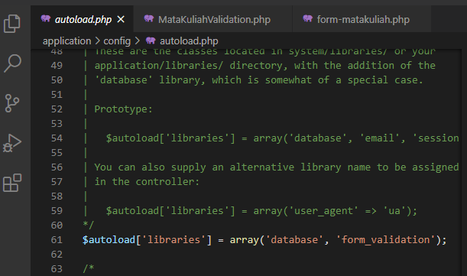

MatakuliahValidation.php => application / controller

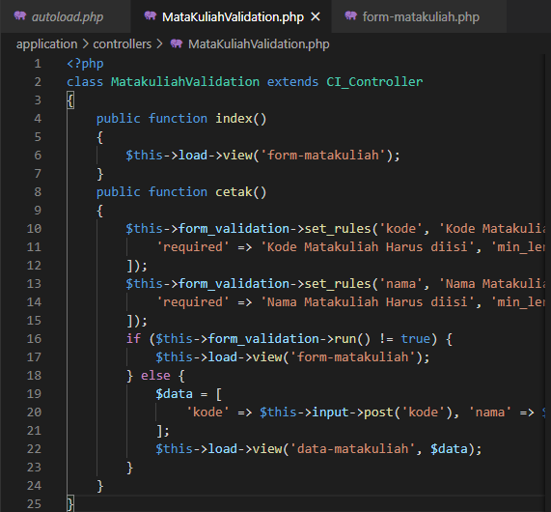

form-matakuliah.php => application / views

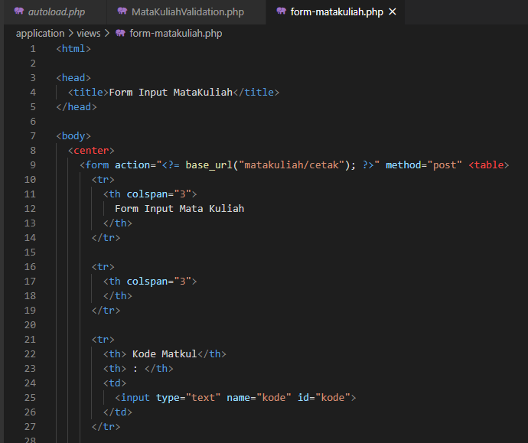

1. URL

<http://localhost/pustaka-booking/MatakuliahValidation>

1. Capture Hasil

